Write a C program to find the reverse of a given number.

#include<stdio.h>

main()

{

**int** n, reverse=0, rem;

printf("Enter a number: ");

  scanf("%d", &n);

**while**(n!=0)

  {

     rem=n%10;

     reverse=reverse*10+rem;

     n/=10;

  }

  printf("Reversed Number: %d",reverse);

}

Write a C program that calculates marks and average of a student.

Average Grade

90-100 A

80-89 B

70-79 C

60-69 D

0-59 F

#include <stdio.h>

main()

{

float marks1, marks2, marks3, average;

printf("Enter marks obtained in subject 1 :");

scanf("%f", &marks1);

printf("Enter marks obtained in subject 2 :");

scanf("%f", &marks2);

printf("Enter marks obtained in subject 3 :");

scanf("%f", &marks3);

average = (marks1 + marks2 + marks3) / 3;

printf("Average : %0.2f\n", average);

if (average >= 90)

{

printf("Grade A");

}

else if (average >= 80)

{

printf("Grade B");

}

else if (average >= 70)

{

printf("Grade C");

}

else if (average >= 60)

{

printf("Grade D");

}

else

{

printf("Grade F");

}

}

How do you define Searching? What are they? Give example for any one method

**Linear Search Example**

#include<stdio.h>

int main()

{

int a[10],i,n,m,c=0;

printf("Enter the size of an array: ");

scanf("%d",&n);

printf("Enter the elements of the array: ");

for(i=0;i<=n-1;i++)

{

scanf("%d",&a[i]);

}

printf("Enter the number to be search: ");

scanf("%d",&m);

for(i=0;i<=n-1;i++){

if(a[i]==m){

c=1;

break;

}

}

if(c==0)

printf("The number is not in the list");

else

printf("The number is found");

}

**Binary Search example**

#include<stdio.h>

main(){

int a[10],i,n,m,c=0,l,u,mid;

printf("Enter the size of an array: ");

scanf("%d",&n);

printf("Enter the elements in ascending order: ");

for(i=0;i<n;i++){

scanf("%d",&a[i]);

}

printf("Enter the number to be search: ");

scanf("%d",&m);

l=0,u=n-1;

while(l<=u)

{

mid=(l+u)/2;

if(m==a[mid])

{

c=1;

break;

}

else if(m<a[mid])

{

u=mid-1;

}

else

l=mid+1;

}

if(c==0)

printf("The number is not found.");

else

printf("The number is found.");

}

Discuss break and continue statements with examples for each.

**break example**

#include<stdio.h>

main()

{

int i;

for(i=1;i<=10;i++)

{

if(i==5)

break;

printf("%d\t",i);

}

printf("\n Breaks the iterations and comes out of the loop at x == %d\n",i);

}

**OUTPUT:** 1 2 3 4

Breaks the iterations and comes out of the loop at x == 5

**continue statement with example**

#include<stdio.h>

main()

{

int i;

for(i=1;i<=10;i++)

{

if(i==5)

continue;

printf("%d\t",i);

}

printf("\n continue skip the iteration I == 5 and continue the loop up to 10\n");

}

OUTPUT: 1 2 3 4 6 7 8 9 10

Continue skip the iteration I == 5 and continue the loop up to 10

Write a C program to find the transpose of a matrix

#include<stdio.h>

void main()

{

int a[10][10],i,j,r,c;

printf("Enter the matrix size r and c(rows and columns)\n");

scanf("%d%d",&r,&c);

printf("Enter the matrix elements\n");

for(i=0;i<r;i++)

for(j=0;j<c;j++)

scanf("%d",&a[i][j]);

printf("Matrix before transpose\n");

for(i=0;i<r;i++)

{for(j=0;j<c;j++)

printf("%d ",a[i][j]);

printf("\n");

}

printf("Matrix after transpose\n");

for(i=0;i<c;i++)

{for(j=0;j<r;j++)

printf("%d ",a[j][i]);

printf("\n");

}

}

Explain Switch Statement with syntax. Write a c program to perform different operation on numbers using switch statement.

/* Calculator program using switch case */

#include<stdio.h>

main()

{

int a,b,c,n;

printf(“Enter two no’s\n”);

scanf(“%d %d”, &a,&b);

printf(“1.Addition\n2.Substration\n3.Multiplication\n4.Division scanf(“%d”,n)

switch(n)

{

case 1 :

c = a + b;

break;

case 2 :

c = a – b;

break;

case 3 :

c = a * b;

break;

case 4 :

c = a / b;

break;

default :

printf(“Invalid Number\n”);

}

printf(“%d”,c);

}

Write a c Program to find the factorial of a given number.

#include<stdio.h>

 main()

{

**int** i,fact=1,number;

 printf("Enter a number: ");

  scanf("%d",&number);

**for**(i=1;i<=number;i++)

{

      fact=fact*i;

  }

  printf("Factorial of %d is: %d",number,fact);

}

Draw a flowchart to find roots of a quadratic equation

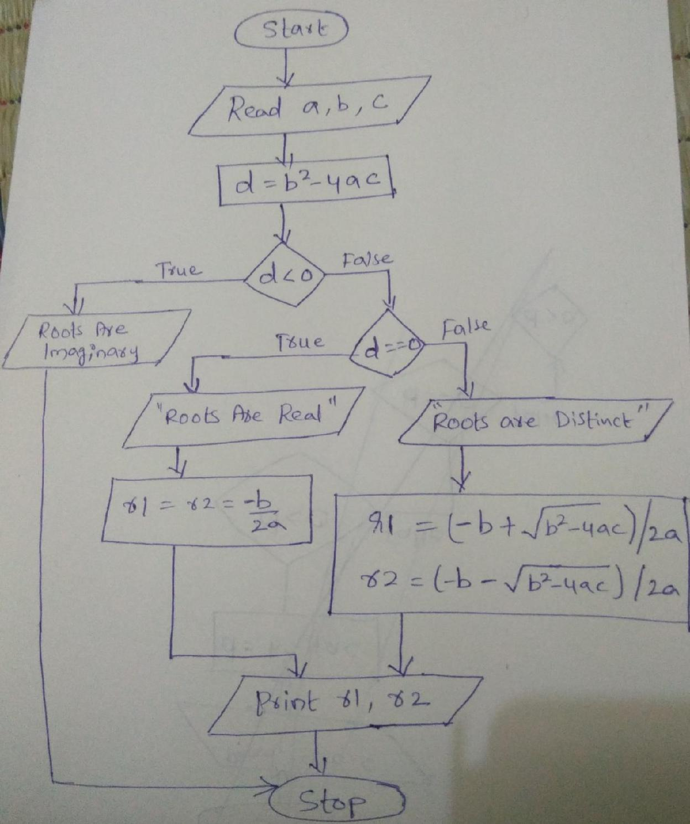

Draw a flowchart for to find the greatest among three numbers.

